Denver Foothills Tracking Association
  - January 1, 2016

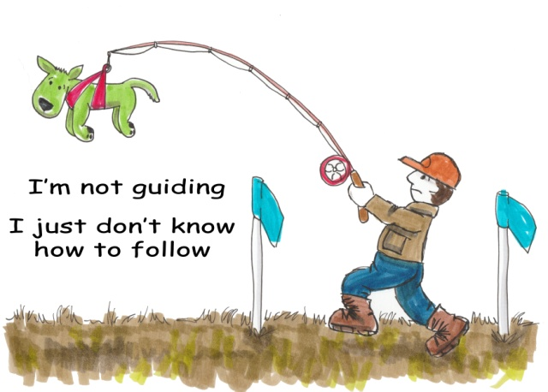 |   Zippered Sweatshirt  small – XL $40  2XL – 3XL $45 |   Long Sleeve Tee  small – XL $30 2XL – 5XL $33 |   T-Shirt  small – XL $25  2XL – 5XL $27
Delivery Method: Ship Deliver at Tracking Test | Shipping Costs
  Name:
  Address
  Phone
  Hoodie: $10.00 for first hoodie/$3 for second hoodie or tee shirt to same address
  Tee Shirts: $6.00 for first shirt/ $3.00 for each additional shirt to same address

Qty. | Item# | Description | Size | Unit Price | Line Total
 |  |  |  | Shipping
 |  |  |  | Total
Check Number __________________________
DATE SENT __________________________

Send to: Lynn Kaemmerer, 1 Glenridge Drive, Littleton CO 80123

